Main Key Terms
Part One IT Project Management

- Introduction To Project Management
project, project management, project manager (hard and soft skills), stakeholders, triple constraint, Project management knowledge areas, PMI, PMO, PMP

- The Project Management and Information Technology Context
Deliverable, project life cycle, systems development life cycle (SDLC)

- Project Management Process Groups: A Case Study
5 process groups, process groups and KAs mapping

- Project Integration Management
project integration management, project charter, project management plan, scope statement, Net Present Value (NPV), Return Of Investment（ROI）

- Project Scope Management
project scope management, scope planning, scope control, scope definition, work breakdown structure(WBS), WBS dictionary

- Project Time Management
Activity definition, activity sequencing (FS,SF,FF,SS), activity resource estimating, activity duration estimating, schedule development, schedule control, milestone, Gantt chart, network diagram, critical path, PERT, AOA(ADM箭头表示活动), PDM, types of dependencies between activities

- Project Cost Management
project cost management, earned value management(EVM), cost estimating, cost budgeting, life cycle costing, Resource estimating, sunk cost

- Project Quality Management
project quality management, quality assurance, quality planning, quality control, Deming's definition of Quality, Pareto analysis, fishbone diagrams(因果图), Standard deviation

- Project Human resource Management
Project human resource planning, Acquiring the project team, Developing the project team, Maslow’s Hierarchy of Needs(生理、安全、social,self-actualization), Covey and Improving Effectiveness, Myers-Briggs Type Indicator(MBTI)(IT人和其他人不一样不是外向的和感性的), Deming's definition of Quality, conflict resolution

- Project Communications Management
Communications planning, Performance Reporting(let everyone know how the project is goiong;status report(at which point), progress report(complete what), forecast), Managing Stakeholders, Conflict management plan, communication channels(formal ,oral, content, face-to-face, meeting)

- Project Risk Management
Project Risk, Negative risk, Positive risk, Brainstorming, Risk management planning, Contingency(意外事故) plans

- Project Procurement management
Project Procurement management, Planning purchases and acquisitions, Selecting sellers, Administering the contract, Closing the contract

Part Two Quality Engineering

- CMMI
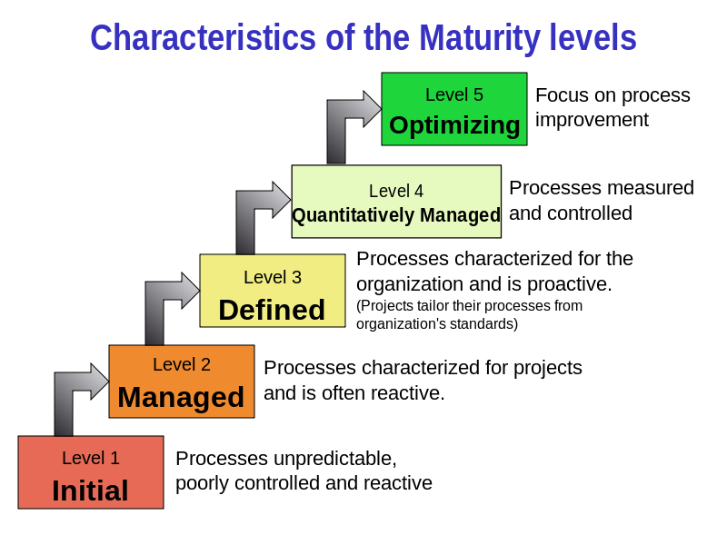

- IOS9001

The types of the final test exercises:
- Explanation Terms
- True or False
- Choose
- Calculation
- Comprehensive question

